Activations are done when variables incremented, top most value of stack is utilized inside local functions

Head recursion

In head recursion, the recursive call is made **before** any operations are performed. This means that the function continues to call itself and does not perform any operations until it reaches the base case. Once the base case is reached, the operations are performed during the return phase of the recursion.

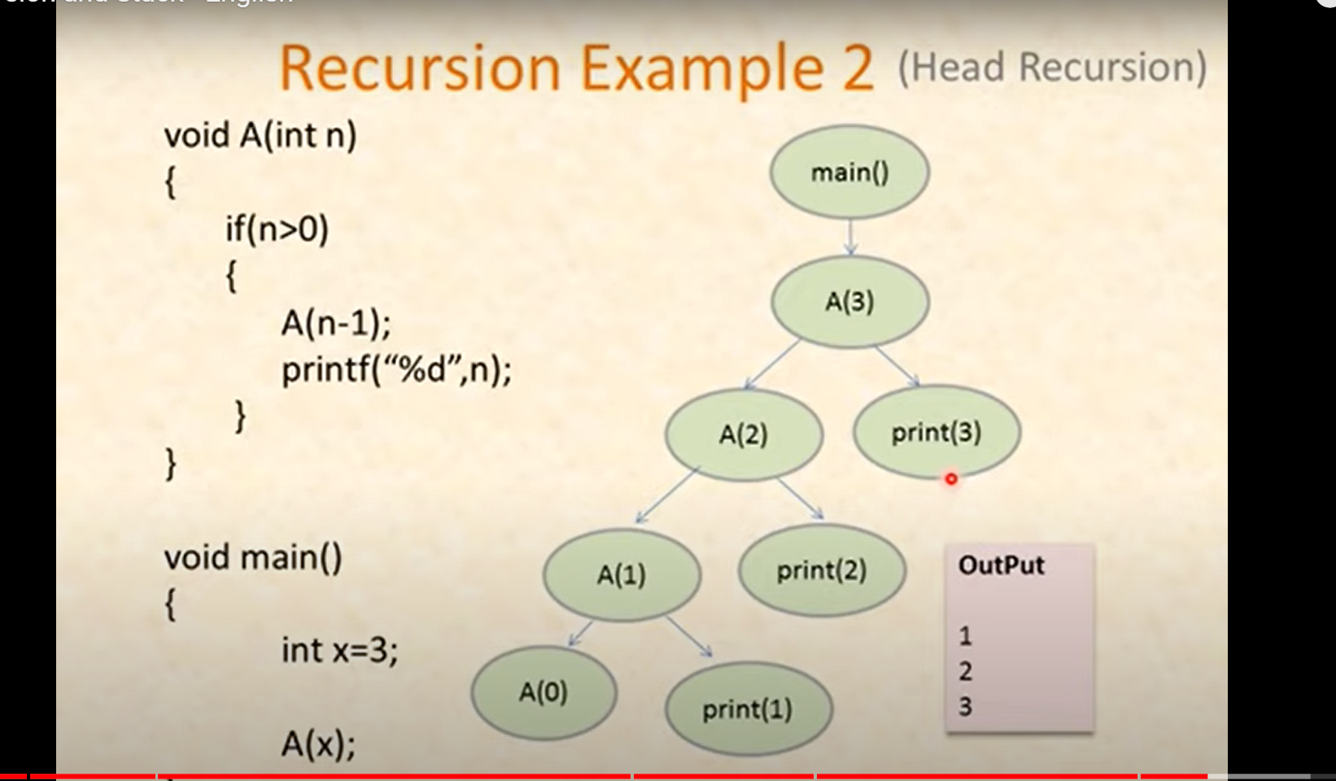

Tail Recursion

In tail recursion, the recursive call is made **after** the operations are performed. The key point in tail recursion is that the recursive call is the last operation in the function. Because of this, there is no need to retain any state after the call, allowing for potential optimization by the compiler (known as tail call optimization).

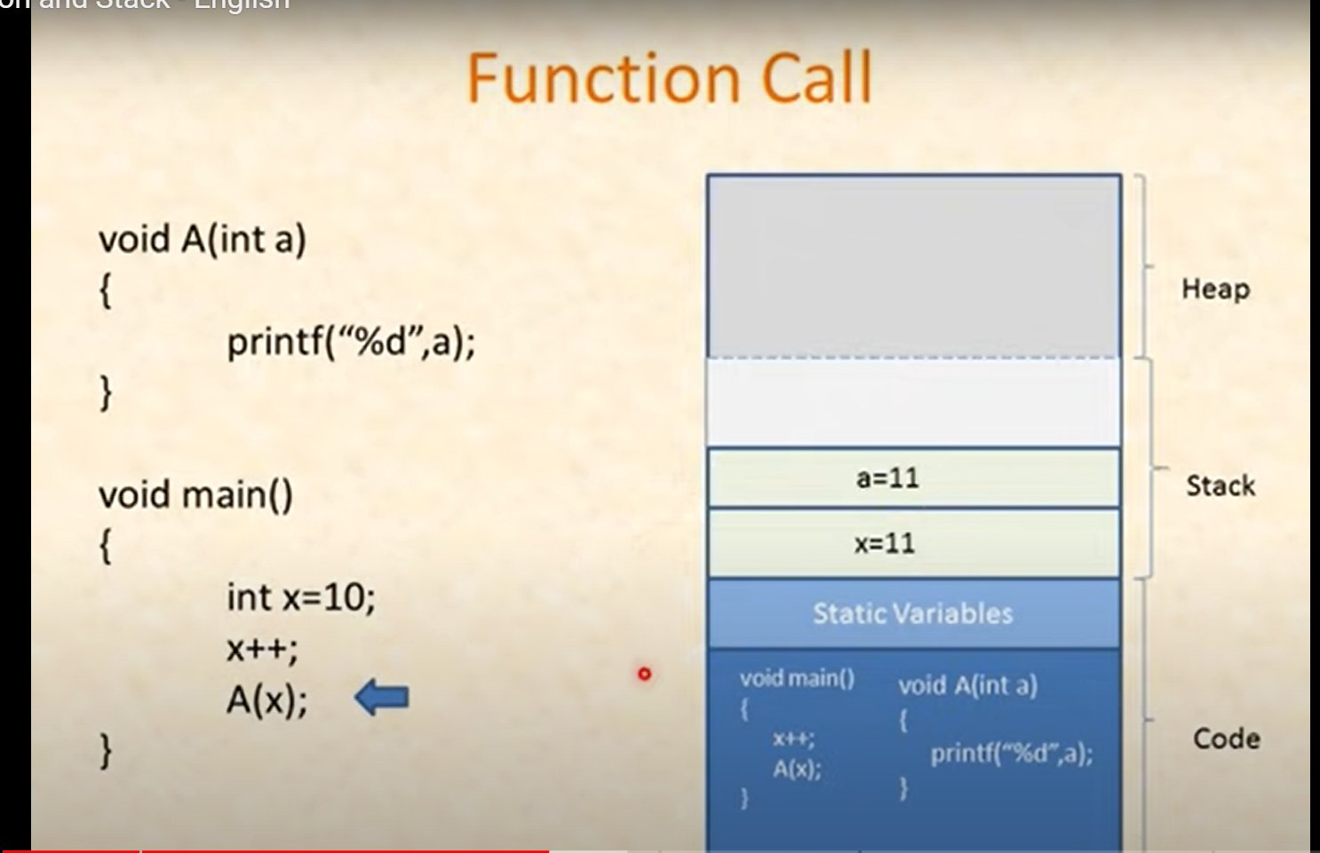

Start from I and then n-i-1 will give us right element for reversing palindrom in recurresion

F(s,i) { if s[i] != s[n-i-1] return False return F(s,i+1) }